**Table of Contents**

1. Entity Relationship Diagram.........................................1

2. Tables

2.1 Fact tables

2.2 Rental.............................................................. 3

2.3 Payment………………………………………..3

2.3 Dimension tables 2.1

1.Film Actor....................................................3

2. Actor .............................................................3

3. Inventory ......................................................4

4.Film....................................................4

5.Language............................................................ 5

6 .Category...................................................5

7.Film_category .............................................5

8. Rental.....................................................5

9.Customer..................................................... 5

10.Staff...................................................... 6

11.Store.............................................................6

12.Address............................................................ 6

13.City………………………………………………………7

14.Country……………………………………………..7

**Step 1. Extract the ERD**

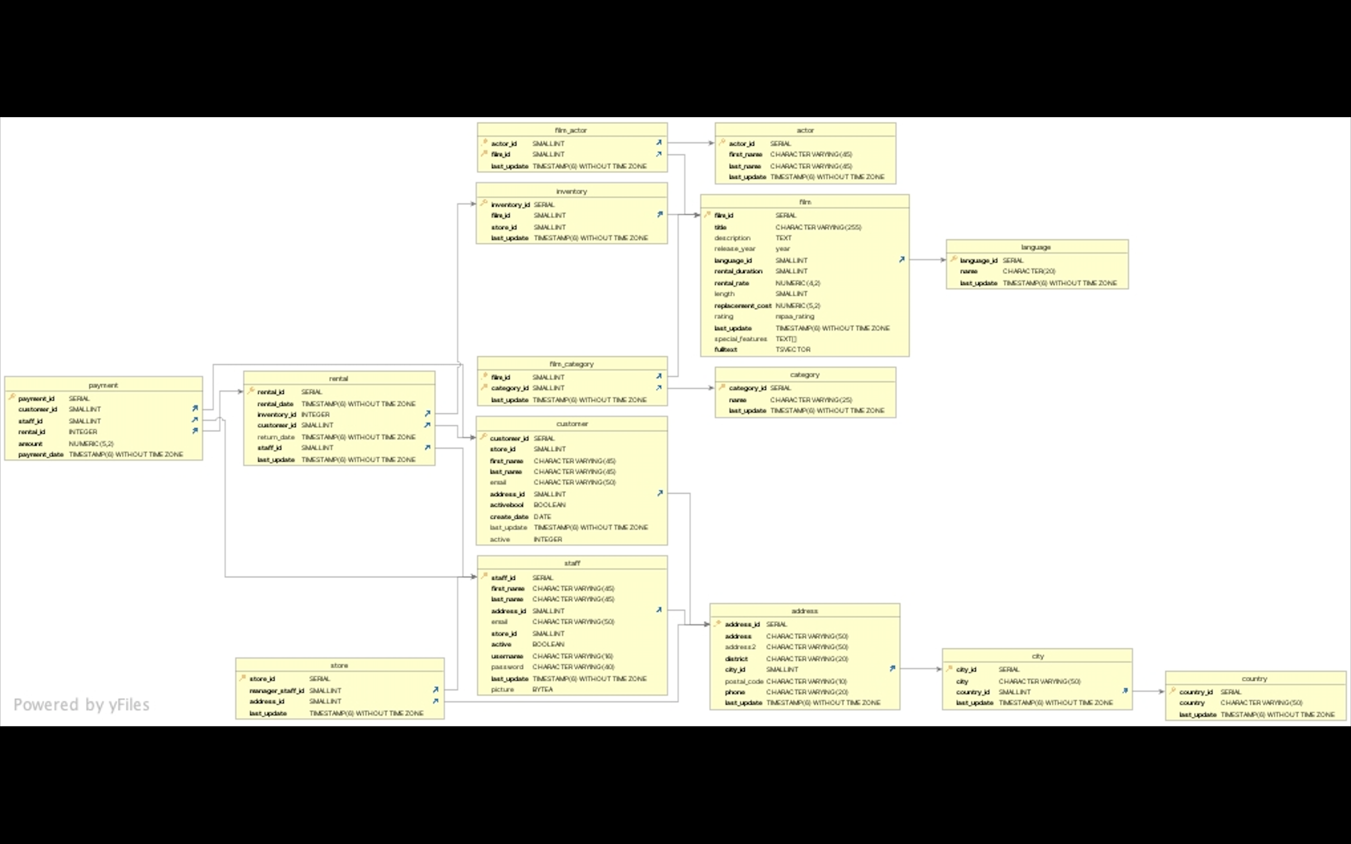

**2.Fact Table**

|  |  |  |  |
| --- | --- | --- | --- |
| **Table Name** | **Colum** | **Data Type** | **Description** |
| Rental Table | rental_ id | serial | ID of rental |
|  | Rental_ date | Timestamp w/o Time Zone | Date of rental |
|  | Inventory _id | integer | ID of inventory |
|  | Customer _id | smallint | ID of customer |
|  | Return_ date | Timestamp w/o Time Zone | Date movie was returned |
|  | Staff _id | Smallint | ID of staff |
|  | Last _update | Timestamp w/o Time Zone | Last update of table |
| Payment | payment_id | serial | ID of payment |
|  | customer_id | smallint | ID of customer |
|  | staff_id | smallint | ID of staff |
|  | rental_id | integer | ID of rental |
|  | amount | numeric(5,2) | Cost of rental |
|  | payment_date | Timestamp w/o Time Zone | Date payment was made |

**Dimensions Table**

|  |  |  |  |
| --- | --- | --- | --- |
| **Table Name** | **Colum** | **Data Type** | **Description** |
| film_actor | actor_id | Smallint | ID for actor |
|  | film_id | Smallint | ID for film |
|  | last_update | Timestamp w/o Time Zone | Last update of table |
| actor | actor_id | Serial | ID for actor |
|  | first_name | Character varying(45) | Actor first name |
|  | last_name | Character varying(45) | Actor last name |
|  | last_update | Timestamp w/o Time Zone | Last update of table |
| Inventory | inventory_id | serial | ID for inventory item |
|  | film_id | smallint | ID for film |
|  | store_id | smallint | ID for store |
|  | last_update | Timestamp w/o Time Zone |  |
| Film | film_id | serial | ID for Film |
|  | title | varchar | Title of Film |
|  | description | text | Description of Film |
|  | release_year | year | Release year of Film |
|  | language_id | int2 | Language of Film |
|  | rental_duration | int2 | Rental Duration of film |
|  | rental_rate | numeric | Rental rate of film |
|  | length | int2 | Lenghth of Film |
|  | replacement_cost | numeric | Replacement Cost if not refunded |
|  | rating | mpaa_rating | Rating of Film |
|  | last_update | timestamp | Last update of table |
|  | special_features | _text | Feature of film |
|  | fulltext | tsvector | Film Index |
| Language | language_id | serial | Id of language |
|  | name | bpchar | Name of Language |
|  | last_update | timestamp | Last update of table |
| Category | category_id | serial | ID of Category |
|  | name | varchar | Name of Category |
|  | last_update | timestamp | Last update of table |
| Film Category | film_id | int2 | ID for Film Category |
|  | category_id | int2 | ID for Film Category |
|  | last_update | timestamp | Last update of table |
| Rental | rental_id | serial | ID for Rental |
|  | rental_date | timestamp | Date of Rental |
|  | inventory_id | int4 | Id of Inventory |
|  | customer_id | int2 | Id for customer |
|  | return_date | timestamp | Date movie was returned |
|  | staff_id | int2 | Id of Staff |
|  | last_update | timestamp | Last update of table |
| Payment | payment_id | serial | Id for payment |
|  | customer_id | int2 | Id for customer |
|  | staff_id | int2 | Id of Staff |
|  | rental_id | int4 | ID for Rental |
|  | amount | numeric | Cost of rental |
|  | payment_date | timestamp | Date Payment Was made |
| customer | customer_id | serial | Id for customer |
|  | store_id | int2 | id for store |
|  | first_name | varchar | Customer first name |
|  | last_name | varchar | Customer last name |
|  | email | varchar | Email of customer |
|  | address_id | int2 | address of customer |
|  | activebool | bool | Whether customer is active |
|  | create_date | date | created date of customer |
|  | last_update | timestamp | Last update of table |
|  | active | int4 | active customer |
| Staff | staff_id | serial | Id of Staff |
|  | first_name | varchar | first name of staff |
|  | last_name | varchar | last name of staff |
|  | address_id | int2 | address od staff |
|  | email | varchar | Email of Staff |
|  | store_id | int2 | store id of staff |
|  | active | bool | Active Staff |
|  | username | varchar | username of staff |
|  | password | varchar | password of staff |
|  | last_update | timestamp | last name of staff |
|  | picture | bytea | picture of satff |
| Store | store_id | serial | Id of store |
|  | manager_staff_id | int2 | Id of store manager and staff |
|  | address_id | int2 | addredd id of store |
|  | last_update | timestamp | Last update of table |
| Address | address_id | serial | ID for adress |
|  | address | varchar | adress1 |
|  | address2 | varchar | addredd 2 |
|  | district | varchar | district |
|  | city_id | int2 | ID of CITY |
|  | postal_code | varchar | Postcode |
|  | phone | varchar | Phone Number |
|  | last_update | timestamp | Last update of table |
| City | city_id | serial | ID for City |
|  | city | varchar | City |
|  | country_id | int2 | ID for Country |
|  | last_update | timestamp | Last update of table |
| Country | country_id | serial | Id for Country |
|  | country | varchar | Country |
|  | last_update | timestamp | Last update of table |